Prediction Analysis
Estimated time needed: 60 minutes
Space X advertises Falcon 9 rocket launches on its website with a cost of 62 million dollars; other providers cost upward of 165 million dollars each, much of the savings is because Space X can reuse the first stage. Therefore if we can determine if the first stage will land, we can determine the cost of a launch. This information can be used if an alternate company wants to bid against space X for a rocket launch. In this lab, you will create a machine learning pipeline to predict if the first stage will land given the data from the preceding labs.
Most unsuccessful landings are planned. Space X; performs a controlled landing in the oceans.
Objectives
Perform exploratory Data Analysis and determine Training Labels
- create a column for the class
- Standardize the data
- Split into training data and test data
-Find best Hyperparameter for SVM, Classification Trees and Logistic Regression
- Find the method performs best using test data
Import Libraries and Define Auxiliary Functions¶
import piplite
await piplite.install(['numpy'])
await piplite.install(['pandas'])
await piplite.install(['seaborn'])
We will import the following libraries for the lab
# Pandas is a software library written for the Python programming language for data manipulation and analysis.
import pandas as pd
# NumPy is a library for the Python programming language, adding support for large, multi-dimensional arrays and matrices, along with a large collection of high-level mathematical functions to operate on these arrays
import numpy as np
# Matplotlib is a plotting library for python and pyplot gives us a MatLab like plotting framework. We will use this in our plotter function to plot data.
import matplotlib.pyplot as plt
#Seaborn is a Python data visualization library based on matplotlib. It provides a high-level interface for drawing attractive and informative statistical graphics
import seaborn as sns
# Preprocessing allows us to standarsize our data
from sklearn import preprocessing
# Allows us to split our data into training and testing data
from sklearn.model_selection import train_test_split
# Allows us to test parameters of classification algorithms and find the best one
from sklearn.model_selection import GridSearchCV
# Logistic Regression classification algorithm
from sklearn.linear_model import LogisticRegression
# Support Vector Machine classification algorithm
from sklearn.svm import SVC
# Decision Tree classification algorithm
from sklearn.tree import DecisionTreeClassifier
# K Nearest Neighbors classification algorithm
from sklearn.neighbors import KNeighborsClassifier
This function is to plot the confusion matrix.
def plot_confusion_matrix(y,y_predict):
"this function plots the confusion matrix"
from sklearn.metrics import confusion_matrix

cm = confusion_matrix(y, y_predict)
ax= plt.subplot()
sns.heatmap(cm, annot=True, ax = ax); #annot=True to annotate cells
ax.set_xlabel('Predicted labels')
ax.set_ylabel('True labels')
ax.set_title('Confusion Matrix');
ax.xaxis.set_ticklabels(['did not land', 'land']); ax.yaxis.set_ticklabels(['did not land', 'landed'])
plt.show()
Load the dataframe
Load the data
from js import fetch
import io

URL1 = "https://cf-courses-data.s3.us.cloud-object-storage.appdomain.cloud/IBM-DS0321EN-SkillsNetwork/datasets/dataset_part_2.csv"
resp1 = await fetch(URL1)
text1 = io.BytesIO((await resp1.arrayBuffer()).to_py())
data = pd.read_csv(text1)
Then
data.head()
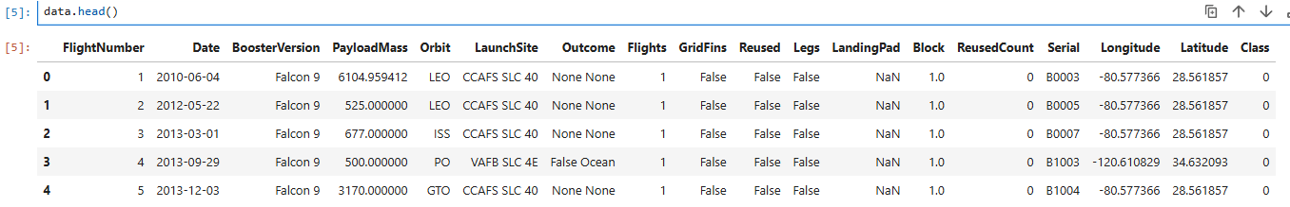
URL2 = 'https://cf-courses-data.s3.us.cloud-object-storage.appdomain.cloud/IBM-DS0321EN-SkillsNetwork/datasets/dataset_part_3.csv'
resp2 = await fetch(URL2)
text2 = io.BytesIO((await resp2.arrayBuffer()).to_py())
X = pd.read_csv(text2)
Then
X.head(100)
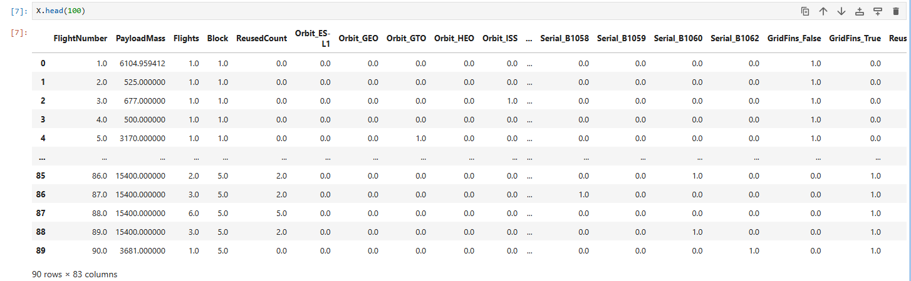
Create a NumPy array from the column Class in data, by applying the method to_numpy() then assign it to the variable Y, make sure the output is a Pandas series (only one bracket df['name of column']).
Y = data['Class'].to_numpy()
TASK 2
Standardize the data in X then reassign it to the variable X using the transform provided below.
# Standardize X
transform = preprocessing.StandardScaler()
X = transform.fit_transform(X)
We split the data into training and testing data using the function train_test_split. The training data is divided into validation data, a second set used for training data; then the models are trained and hyperparameters are selected using the function GridSearchCV.
TASK 3
Use the function train_test_split to split the data X and Y into training and test data. Set the parameter test_size to 0.2 and random_state to 2. The training data and test data should be assigned to the following labels.
X_train, X_test, Y_train, Y_test
X_train, X_test, Y_train, Y_test=train_test_split(X, Y, test_size=0.2, random_state=2)
we can see we only have 18 test samples.
Y_test.shape
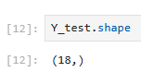
TASK 4
Create a logistic regression object then create a GridSearchCV object logreg_cv with cv = 10. Fit the object to find the best parameters from the dictionary parameters.
# Define the parameter grid
parameters ={'C':[0.01,0.1,1],
'penalty':['l2'],
'solver':['lbfgs']}

# Create logistic regression object
logreg = LogisticRegression()

# Create GridSearchCV object wtih cv=10
logreg_cv = GridSearchCV(logreg, parameters, cv=10)

# Fit the training data
logreg_cv.fit(X_train, Y_train)
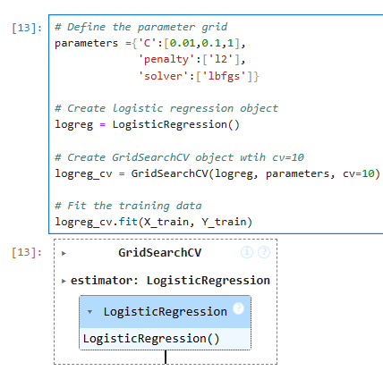
parameters ={"C":[0.01,0.1,1],'penalty':['l2'], 'solver':['lbfgs']}# l1 lasso l2 ridge
lr=LogisticRegression()
We output the GridSearchCV object for logistic regression. We display the best parameters using the data attribute best_params_ and the accuracy on the validation data using the data attribute best_score_.
print("tuned hpyerparameters :(best parameters) ",logreg_cv.best_params_)
print("accuracy :",logreg_cv.best_score_)
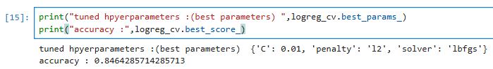
TASK 5
Calculate the accuracy on the test data using the method score:
# Calculate the accuracy on the test data using score
accuracy = logreg_cv.score(X_test, Y_test)
print("Test Accuracy:", accuracy)
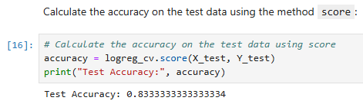
Lets look at the confusion matrix:
yhat=logreg_cv.predict(X_test)
plot_confusion_matrix(Y_test,yhat)
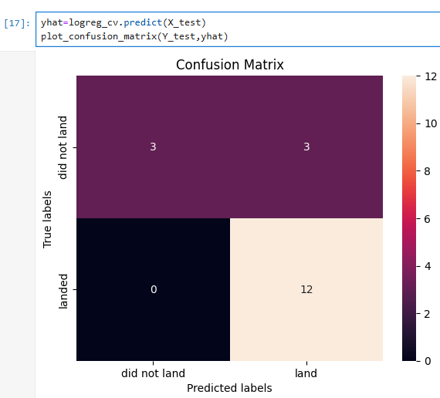
Examining the confusion matrix, we see that logistic regression can distinguish between the different classes. We see that the problem is false positives.
Overview:
True Postive - 12 (True label is landed, Predicted label is also landed)
False Postive - 3 (True label is not landed, Predicted label is landed)
TASK 6
Create a support vector machine object then create a GridSearchCV object svm_cv with cv = 10. Fit the object to find the best parameters from the dictionary parameters.
# Define the parameter grid
parameters = {'kernel':('linear', 'rbf','poly','rbf', 'sigmoid'),
'C': np.logspace(-3, 3, 5),
'gamma':np.logspace(-3, 3, 5)}
# Create the SVM object
svm = SVC()
# Create GridSearchCV object with cv=10
svm_cv = GridSearchCV(svm, parameters, cv=10)

#Fit to training data
svm_cv.fit(X_train, Y_train)
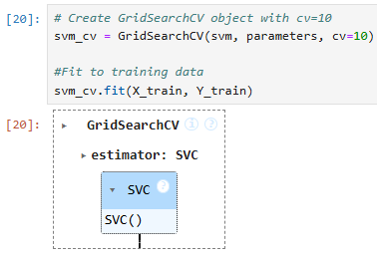
print("tuned hpyerparameters :(best parameters) ",svm_cv.best_params_)
print("accuracy :",svm_cv.best_score_)
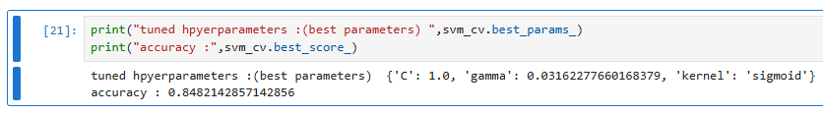
TASK 7
Calculate the accuracy on the test data using the method score:
# Calculate the accuracy on the test data using score
accuracy = svm_cv.score(X_test, Y_test)
print("Test Accuracy:", accuracy)
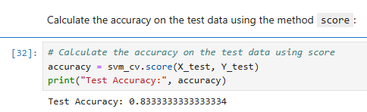
We can plot the confusion matrix
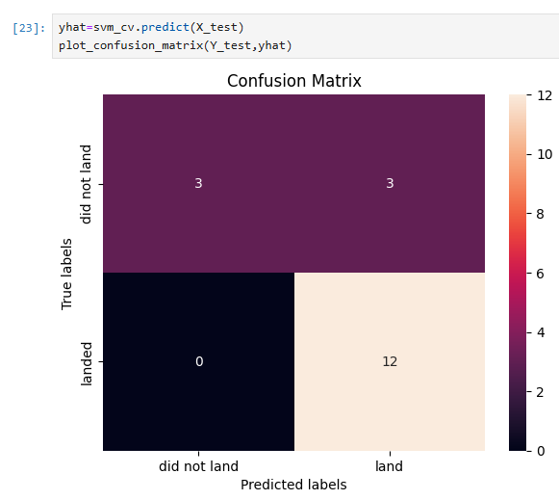
TASK 8
Create a decision tree classifier object then create a GridSearchCV object tree_cv with cv = 10. Fit the object to find the best parameters from the dictionary parameters.
# Define the parameter grid
parameters = {
'criterion': ['gini', 'entropy'],
'splitter': ['best', 'random'],
'max_depth': [2 * n for n in range(1, 10)],
'max_features': ['sqrt', 'log2'], # Removed 'auto'
'min_samples_leaf': [1, 2, 4],
'min_samples_split': [2, 5, 10]}

# Create Decision Tree classifier object
tree = DecisionTreeClassifier()
# Create GridSearchCV object wtih cv=10
tree_cv = GridSearchCV(tree, parameters, cv=10)
# Fit to training data
#tree_cv.fit(X_train, Y_train)
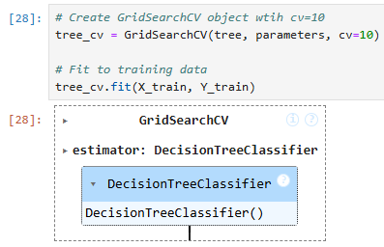
print("tuned hyperparameters :(best parameters) ",tree_cv.best_params_)
print("accuracy :",tree_cv.best_score_)
TASK 9
Calculate the accuracy of tree_cv on the test data using the method score:
# Calculate the accuracy on the test data using score
accuracy = tree_cv.score(X_test, Y_test)
print("Test Accuracy:", accuracy)
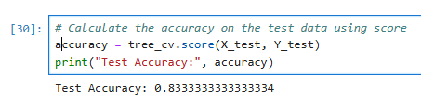
We can plot the confusion matrix
yhat = tree_cv.predict(X_test)
plot_confusion_matrix(Y_test,yhat)
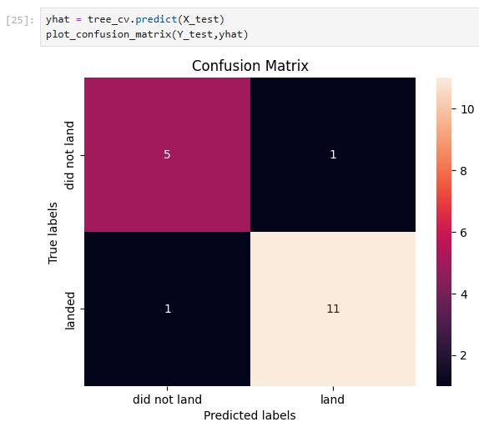
TASK 10
Create a k nearest neighbors object then create a GridSearchCV object knn_cv with cv = 10. Fit the object to find the best parameters from the dictionary parameters.
# Define the parameter grid
parameters = {'n_neighbors': [1, 2, 3, 4, 5, 6, 7, 8, 9, 10],
'algorithm': ['auto', 'ball_tree', 'kd_tree', 'brute'],
'p': [1,2]}

# Create KNN classifier object
KNN = KNeighborsClassifier()
# Create GridSearchCV object wtih cv=10
knn_cv = GridSearchCV(KNN, parameters, cv=10)

# Fit to training data
knn_cv.fit(X_train, Y_train)
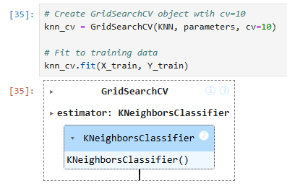
print("tuned hpyerparameters :(best parameters) ",knn_cv.best_params_)
print("accuracy :",knn_cv.best_score_)
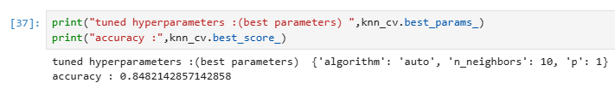
TASK 11
Calculate the accuracy of knn_cv on the test data using the method score:
# Calculate the accuracy on the test data using score
accuracy = knn_cv.score(X_test, Y_test)
print("Test Accuracy:", accuracy)
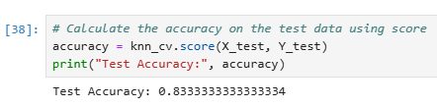
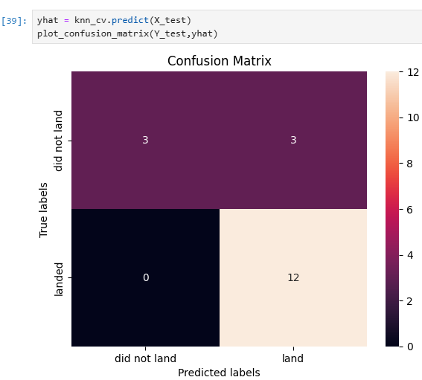
TASK 12
Find the method performs best:
# Accuracy scores on the test set
logreg_score = logreg_cv.score(X_test, Y_test)
svm_score = svm_cv.score(X_test, Y_test)
tree_score = tree_cv.score(X_test, Y_test)
knn_score = knn_cv.score(X_test, Y_test)

# Print results
print("Logistic Regression Test Accuracy:", logreg_score)
print("SVM Test Accuracy:", svm_score)
print("Decision Tree Test Accuracy:", tree_score)
print("KNN Test Accuracy:", knn_score)
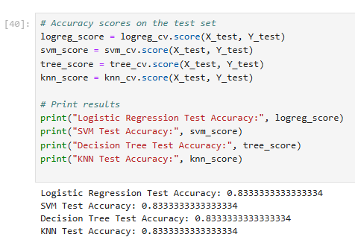
scores = {
'Logistic Regression': logreg_score,
'SVM': svm_score,
'Decision Tree': tree_score,
'KNN': knn_score
}

best_model = max(scores, key=scores.get)
print("Best performing model:", best_model)
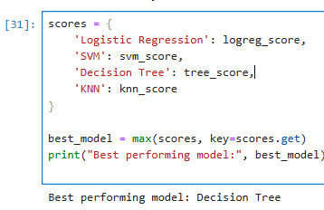
# Accuracy scores
accuracies = {
'Logistic Regression': logreg_cv.score(X_test, Y_test),
'SVM': svm_cv.score(X_test, Y_test),
'Decision Tree': tree_cv.score(X_test, Y_test),
'KNN': knn_cv.score(X_test, Y_test)
}

# Plotting
plt.figure(figsize=(8, 5))
plt.bar(accuracies.keys(), accuracies.values(), color='skyblue')
plt.ylabel('Test Accuracy')
plt.title('Model Comparison: Test Accuracy')
plt.ylim(0, 1)
plt.grid(axis='y', linestyle='--', alpha=0.7)

# Annotate bars with accuracy values
for i, (model, score) in enumerate(accuracies.items()):
plt.text(i, score + 0.01, f"{score:.2f}", ha='center', va='bottom')

plt.tight_layout()
plt.show()
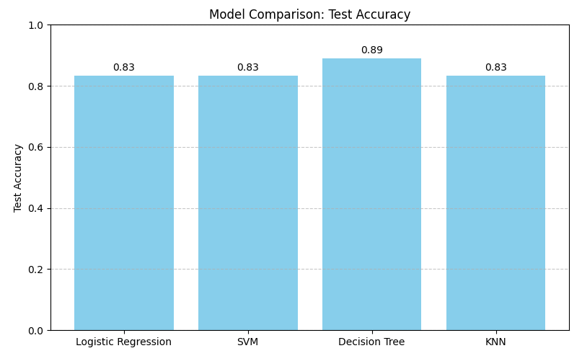

Authors
Pratiksha Verma

